Answer 7
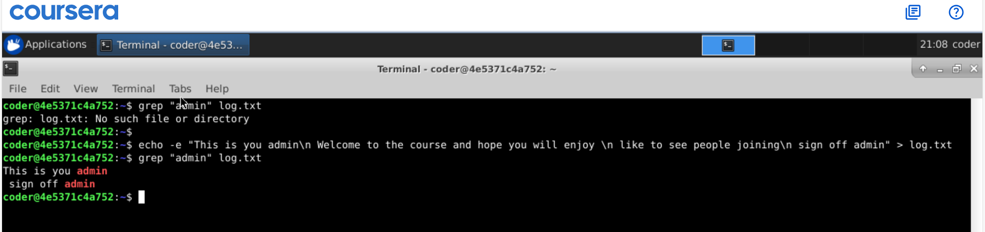
Explanation: As seen using grep command we can show lines containing the matching word, but as there was no file name log.txt got the error message saying No such file exist. But if we create one using echo -e putting some lines of text and do the same command again It would only show the lines containing the text admin

